Forms and Reports servers’ deployment progress screenshots.
**Current status (2026-08-17): The core AWS, Linux, Oracle Fusion Middleware 14.1.2, WebLogic 14.1.2, Forms 14.1.2, Reports 14.1.2, Node Manager, and OHS platform components are deployed on the application server and are being validated. Forms web access and the FSAL download/launch path are working through the local HTTPS test path, but the FSAL client session is currently hanging after launch. Reports Server is running and its configuration is deployed, while the Reports servlet/application path still requires validation. The Employee Management application and production front-end architecture remain in progress.
Application server — OS, Oracle, domain
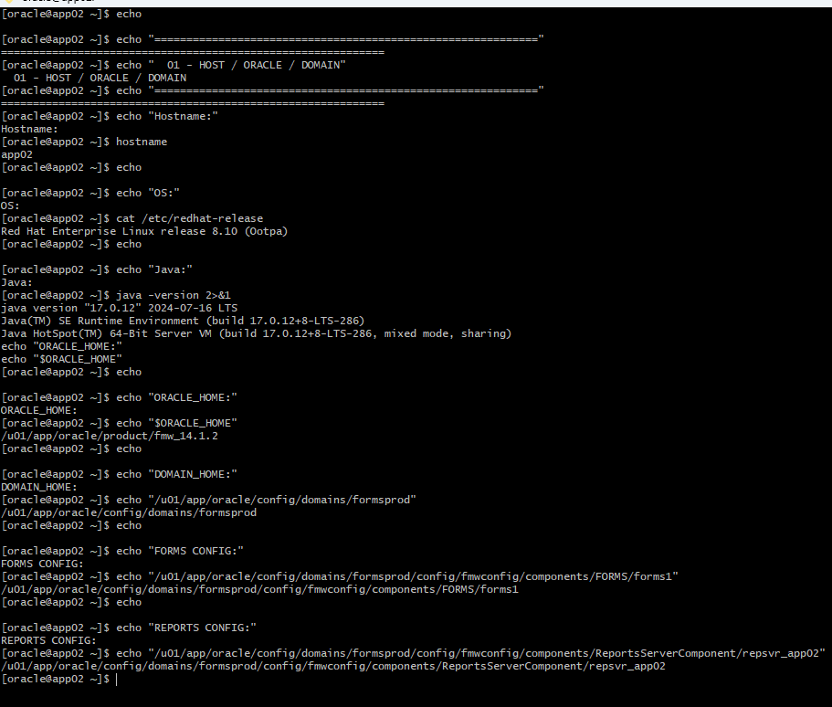

Running Oracle/WebLogic processes:
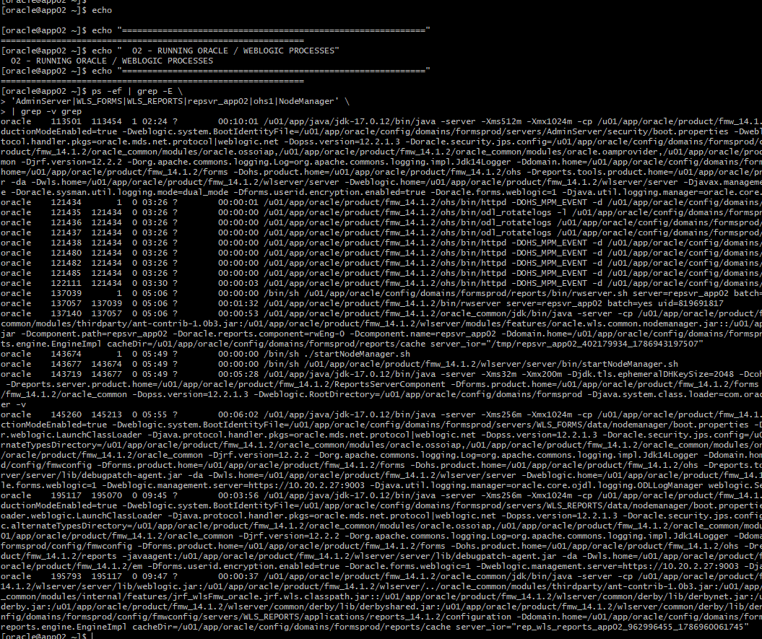
Listening ports:
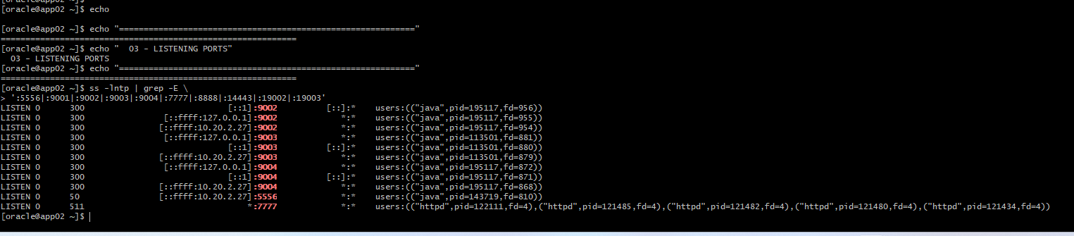

WebLogic domain servers
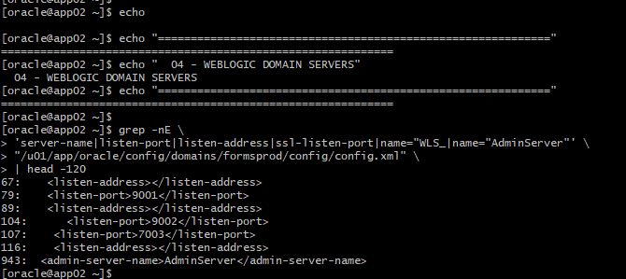
Forms Deployment
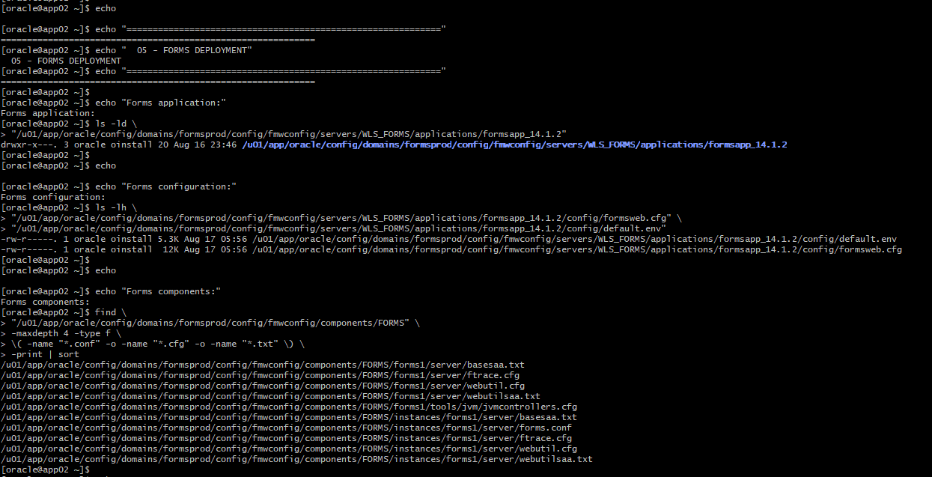
Current Forms Configurations:
[oracle@app02 ~]$ echo

[oracle@app02 ~]$ echo "----- [default] -----"
----- [default] -----
[oracle@app02 ~]$ sed -n '/^\[default\]/,/^\[/{p}' "$FORMSWEB"
[default]
# System parameter: default base HTML file. Contains APPLET tags (no longer supported)
baseHTML=base.htm
# System parameter: base HTML file for use with Java Plug-In (no longer supported)
baseHTMLjpi=basejpi.htm
# System parameter: base JNLP file for use with Java WebStart
basejnlp=base.jnlp
# System parameter: base TXT file for use with Forms Standalone Launcher
baseSAAfile=basesaa.txt
# fsalcheck parameter specifies whether to perform checksum comparison
# of Forms stand-alone app launcher or not. When it is enabled, it triggers
# the comparison at server. The checksum of FSAL at client machine will be
# compared with the checksum of FSAL archived at the server repository.
# Setting to false will also disable automatic updating of the launcher.
# To disable autoupdate while retaining fsalCheck functionality, set
# fsalEnableAutoUpdate to FALSE. Setting fsalCheck to FALSE is not recommended.
fsalcheck=true
#
# System parameter: delimiter for parameters in the base HTML files
HTMLdelimiter=%
# System parameter: file setting environment variables for the Forms runtime processes
envFile=default.env
# System parameter: Forms runtime arguments
serverArgs=%escapeparams% module=%form% userid=%userid% debug=%debug% host=%host% port=%port% %otherparams%
# Forms runtime argument: whether to escape certain special characters
# in values extracted from the URL for other runtime arguments
escapeparams=true
# Forms runtime argument: which form module to run
form=test.fmx
# Forms runtime argument: database connection details
userid=
# Forms runtime argument: whether to run in debug mode
debug=no
# Forms runtime argument: host for debugging
# For internal use. Do not change null value.
host=
# Forms runtime argument: port for debugging
# For internal use. Do not change null value.
port=
# Forms runtime argument: BIDI digitSubstitution
digitSubstitution=context
# Other Forms runtime arguments: grouped together as one parameter.
# These settings support running and debugging a form from the Builder:
otherparams=obr=%obr% record=%record% tracegroup=%tracegroup% log=%log% term=%term% ssoProxyConnect=%ssoProxyConnect% allowJVMControllerAutoStart=%allowJVMControllerAutoStart% jvmController=%jvmController%
# Sub argument for otherparams
obr=no
# Sub argument for otherparams
record=
# Sub argument for otherparams
tracegroup=
# Sub argument for otherparams
log=
# Sub argument for otherparams
term=
# HTML page title
pageTitle=Oracle Fusion Middleware Forms Services
# HTML attributes for the BODY tag
HTMLbodyAttrs=
# HTML to add before the form
HTMLbeforeForm=
# HTML to add after the form
HTMLafterForm=
# Use HTML page title for Forms frames (webstart, standalone, etc.) by default
webFormsTitle=%pageTitle%
# Forms applet parameter: URL path to Forms ListenerServlet
serverURL=/forms/lservlet
# Forms applet parameter
codebase=/forms/java
# Forms applet parameter
imageBase=codebase
# Forms applet parameter: location for media files
mediaBase=codebase
# Forms applet parameter
logoClickURL=
# Forms applet parameter
width=750
# Forms applet parameter
height=600
# Forms applet parameter
separateFrame=false
# Forms applet parameter
splashScreen=
# Forms applet parameter
allowAlertClipboard=true
# Forms applet parameter
disableValidateClipboard=false
# Forms applet parameter, valid range [10-100]
clientDPIRatio=
# Forms applet parameter
honorLineWidth=
# Forms applet parameter
highContrast=false
# Forms applet parameter
background=
# Forms applet parameter
lookAndFeel=Oracle
# Forms applet parameter
colorScheme=swan
# Forms applet parameter to configure custom color scheme
customColorScheme=
# Forms applet parameter
logo=
# Forms applet parameter
hideWindowMenuItem=
# Forms applet parameter, valid range [0-3]
guiMode=0
# Forms applet parameter
restrictedURLparams=pageTitle,HTMLbodyAttrs,HTMLbeforeForm,HTMLafterForm,log
# Forms applet parameter
formsMessageListener=
# Forms applet parameter
recordFileName=
# Forms applet parameter
serverApp=
# Forms applet archive setting for other clients (Java Plugin, Appletviewer, etc)
archive=frmall.jar
# Number of times client should retry if a network failure occurs. You should
# only change this after reading the documentation.
networkRetries=1
#
# More information regarding jpi and java_version settings can be found here:
# https://docs.oracle.com/javase/8/docs/technotes/guides/jweb/applet/using_tags.html
#
# Page displayed to users to allow them to download Oracle's Java Plugin.
# This is typically used for non-Microsoft Internet Explorer clients.
jpi_download_page= https://www.oracle.com/java/technologies/downloads
# Parameter to identify the Java Plugin
jpi_classid=clsid:8AD9C840-044E-11D1-B3E9-00805F499D93
#
# Parameter related to the version of the Java Plugin and a desired download location
#jpi_codebase=http://example.com/somewhere/jre-8u40-windows-i586.exeVersion=1,8,0,40
#
# Parameter related to the version of the Java Plugin
jpi_mimetype=application/x-java-applet
#
# Parameter used to specify which Java version to use with Web Start and FSAL
java_version=1.8+
fsalJavaVersion=%java_version%
#
# Applet parameter for Oracle's Java Plugin when using
# embedded applet configuration (deprecated)
legacy_lifecycle=false
# Single Sign-On configuration parameter: indicates whether to allow
# dynamic resource creation if the resource has not yet been created.
ssoDynamicResourceCreate=true
# Single Sign-On parameter: URL to redirect to if ssoDynamicResourceCreate=false
ssoErrorUrl=
# Single Sign-On parameter: Cancel URL for the dynamic resource creation page.
ssoCancelUrl=
# Single Sign-On parameter: indicates whether the URL is SSO protected
# It is false by default. Set it to true in an application-specific section to
# enable Single Sign-On for that application only.
ssoMode=false
# Single Sign-On parameter: indicates whether session should operate in proxy
# user support or not. Specify ssoProxyConnect=yes to enable for particular application.
ssoProxyConnect=no
# Single Sign-On parameter: indicates whether session should be logged out
# while exiting
ssoLogOut=false
# Single Sign-On parameter: Redirect URL to which the browser should be
# redirected after logging out while exiting the session
ssoLogOutRedirect=
# Single Sign-On parameter: parameter to hold the name of query parameter on SSO Logout
# URL that holds the landing URL.
logoutTargetURLParamname=
# The parameter allow_debug determines whether debugging is permitted.
# Administrators should set allow_debug to "true" if servlet
# debugging is required, or to provide access to the Forms Trace Xlate utility.
# Otherwise these activities will not be allowed (for security reasons).
# See documentation for additional valid values.
allow_debug=false
# Parameter which determines whether new Forms sessions are allowed.
# This is also read by the Forms EM Overview page to show the
# current Forms status.
allowNewConnections=true
# EndUserMonitoring
# EndUserMonitoringEnabled parameter
# Indicates whether EUM/Chronos integration is enabled
EndUserMonitoringEnabled=false
# EndUserMonitoringURL
# indicates where to record EUM/Chronos data
EndUserMonitoringURL=
# Config for javascript integration
applet_name=
enableJavascriptEvent=true
# Config variable that will indicate if heartbeat will
# be blocked when a javascript call is a blocking call.
# The default value if false, i.e heart beat will not be
# blocked for any javascript calls.
JavaScriptBlocksHeartBeat=false
# idleTimeout indicates how many seconds to wait
# before sending a message to the server indicating client-inactivity. Null
# or 0 means this functionality is disabled and there will be no client-idle
# notification.
idleTimeout=
# Setting separate_jvm=true is required for audio support when using
# embedded applet configuration (deprecated)
separate_jvm=false

# Example Named Configuration Section
# Example 1: configuration to run forms in a separate browser window with
# "generic" look and feel (include "config=sepwin" in the URL)
# You may define your own specific, named configurations (sets of parameters)
# by adding special sections as illustrated in the following examples.
# Note that you need only specify the parameters you want to change. The
# default values (defined above) will be used for all other parameters.
# Use of a specific configuration can be requested by including the text
# "config=<your_config_name>" in the query string of the URL used to run
# a form. For example, to use the sepwin configuration, your could issue
# a URL like "http://myhost.example.com/forms/frmservlet?config=sepwin".
[sepwin]
[oracle@app02 ~]$
[oracle@app02 ~]$ echo

[oracle@app02 ~]$ echo "----- Forms Listener -----"
----- Forms Listener -----
[oracle@app02 ~]$ grep -nE 'serverURL|lservlet' "$FORMSWEB"
87:serverURL=/forms/lservlet
241:serverURL=/forms/lservlet/debug
[oracle@app02 ~]$

Reports Server
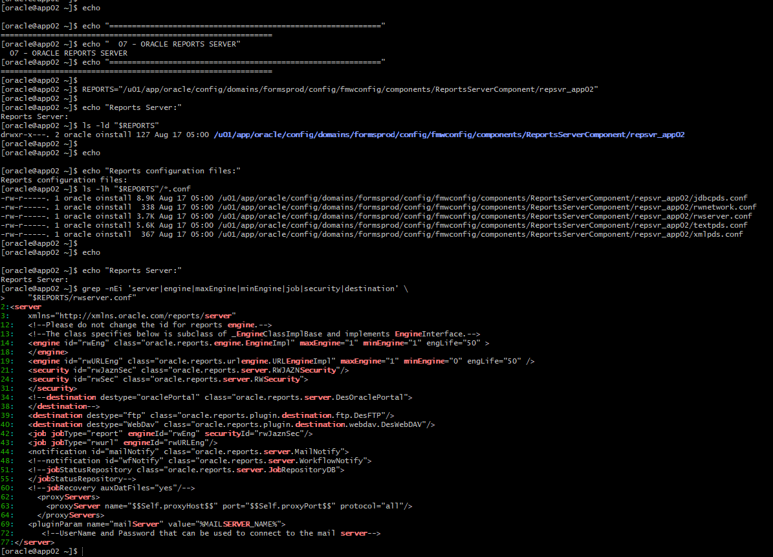

Servers are up, but FSAL hangs.
